**Data Analysis of IPL Matches-2022**

Interesting insights into Indian Premier League

The [dataset](https://www.kaggle.com/nowke9/ipldata?select=matches.csv) consist of data about IPL matches played from the year 2022. The league has 10 teams representing 10 different Indian cities or states. So, let’s analyze IPL through stats.

# Objectives:

* **Batting**

To find the Most Run Scored in IPL by Teams.

To find the Most IPL Runs by a Batsman.

* **Bowling**

To find the Most IPL Wickets by a Bowler.

To find the Most Dot Ball by a Bowler.

* **Catches**

Top 10 Catches in 'caught' category.

Top 10 Catches in 'caught and bowled' category.

* Run Out -Top 5 Run Out by fielders.
* **Toss won**

Most IPL Number of Toss won by Teams.

Most Toss won Decisions by Teams

* Highest run chase team-wise.
* Highest Run scorer in power play and death overs.
* Most runs scored in 20th and19th overs.
* Does winning toss increases the chances of victory.

(Match winner after winning the toss)

* The Lowest total defended and Highest total chased by each team.
* Most Sixes and Most Four by individual and teams.
* Most 50+ 100+ partnerships by a duo
* Most 50+ 100+ partnerships by team

# Loading Libraries

Let us begin our analysis by loading / importing necessary Python libraries

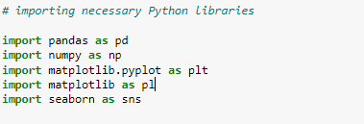

**Data Preparation and Cleaning**

Let’s start by reading the csv file to Pandas DataFrame.

There are two different files where we used for Analysis are:

1. IPL_Matches_2022.csv
2. IPL_Ball_by_Ball_2022.csv
3. **Importing necessary data from python-IPL_Matches_2022.csv**

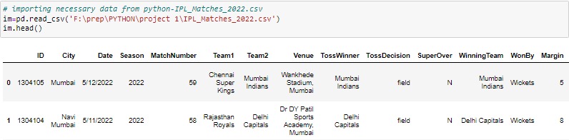

**Get basic information of Data**

The very basic information to know is the dimension of the dataset - rows and columns — that’s what we find out with the method shape.



And then, it is important to know the different types of data/variables in the given dataset.

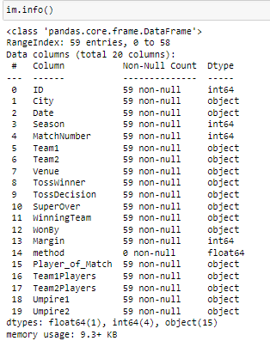

Moving one level up, let’s perform a simple summary statistic using the

method describe ().

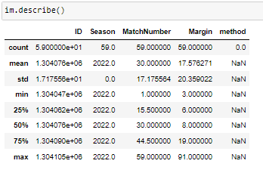

Columns present in the Data; Let’s get acquainted with the columns

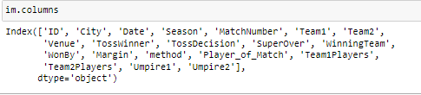

It’s imperative to know the count of NaN values for each column before we proceed further.

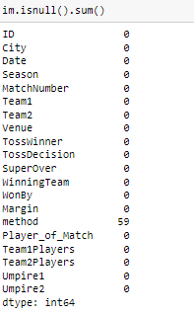

1. **Importing necessary data from python- IPL_Ball_by_Ball_2022.csv**

**Get basic information of Data:**

As like above file we will extract the information of head(), info() ,describe(),columns , isnull()

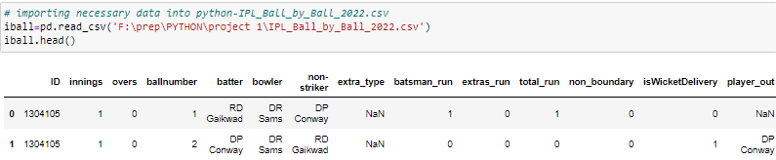



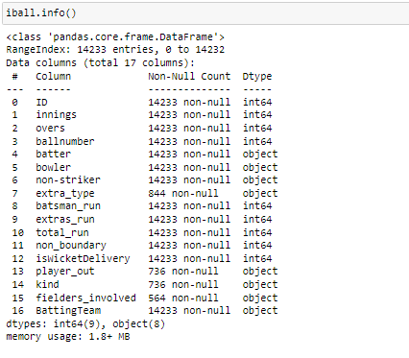

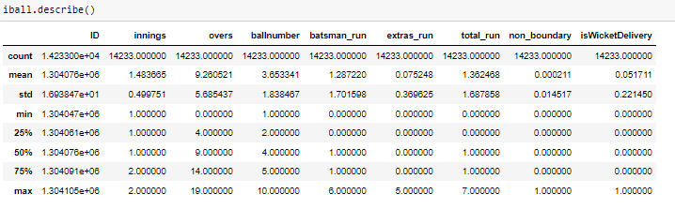

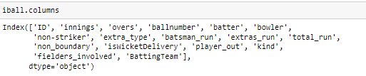

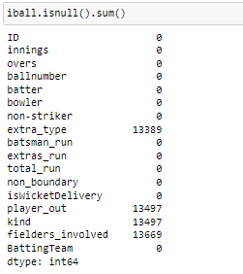

# Exploratory Analysis and Visualization

* **Batting**

1. **To find the Most Run Scored in IPL by Teams.**

Let’s Analyze the Most Run Scored in IPL by Teams.

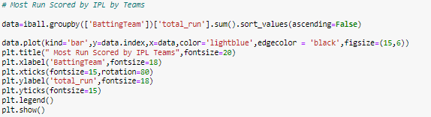

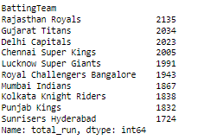

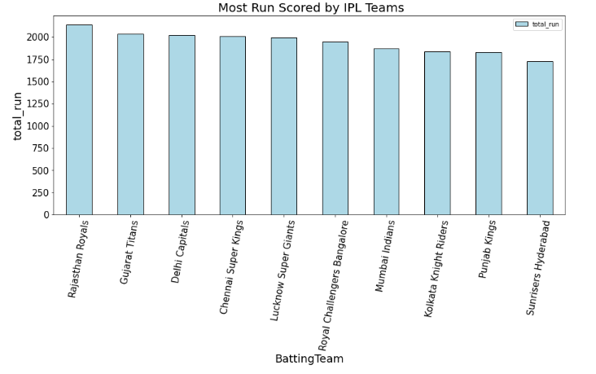

## **Observations:**

**Rajasthan Royals has scored the most runs-2135 in this seasons-2022.**

1. **To find the Most IPL Runs by a Batsman.** 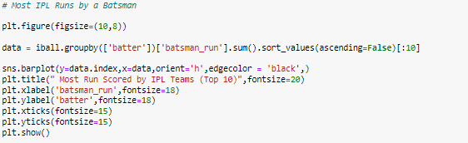 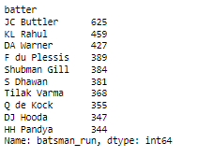
2. 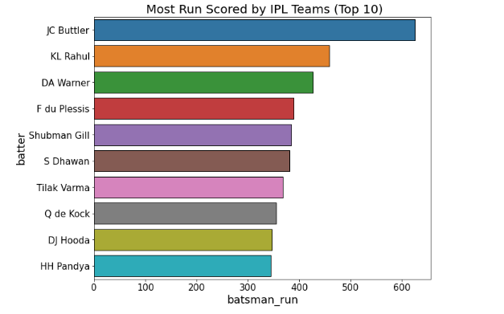

## **Observations:**

**JC Buttler has scored the most runs (625) in this seasons-2022.**

* **Bowling**

1. **To find the Most IPL Wickets by a Bowler:**

Firstly, we need to extract unique values of ‘kind’ column

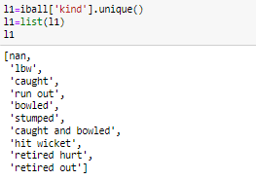

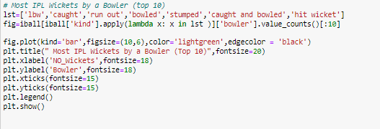

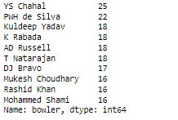

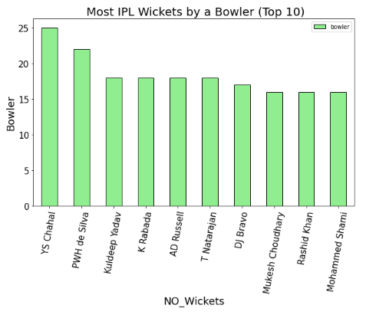

## **Observations:**

Most IPL Wickets by a Bowler **-YS Chahal (25) in this seasons-2022.**

1. **To find the Most Dot Ball by a Bowler**

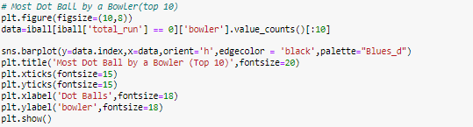

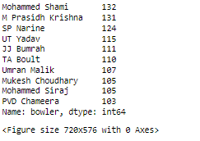

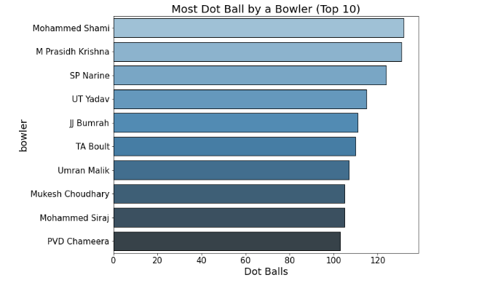

## **Observations:**

Most Dot Ball by a Bowler Mohammed Shami -132

* **Catches**
  1. **Top 10 Catches in 'caught' category**

Firstly, we need to extract unique values of ‘kind’ column

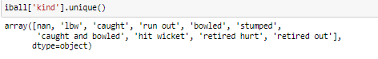

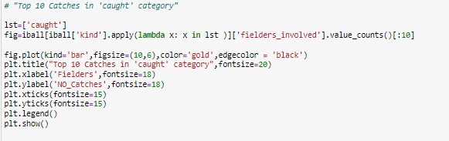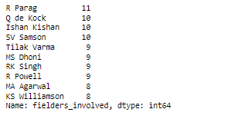

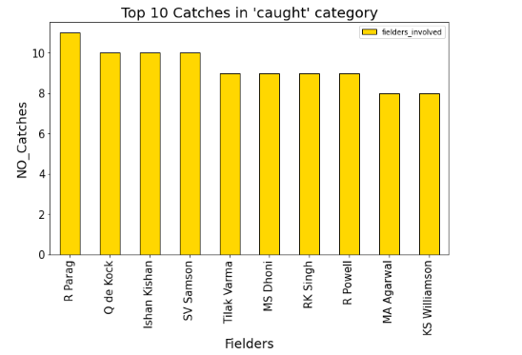

## **Observations:**

Most Catches in 'caught' category is R Parag -11

* 1. **Top 10 Catches in 'caught and bowled' category.**

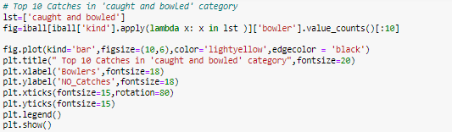

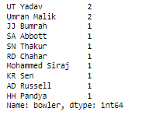

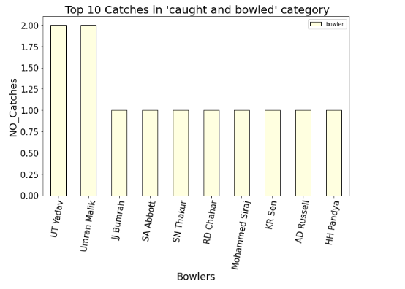

## **Observations**:

Most Catches in 'caught and bowled' category is UT Yadav-2

**Top 5 Run Out by fielders.**

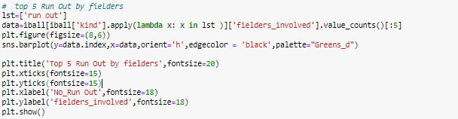

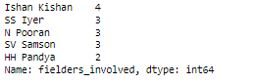

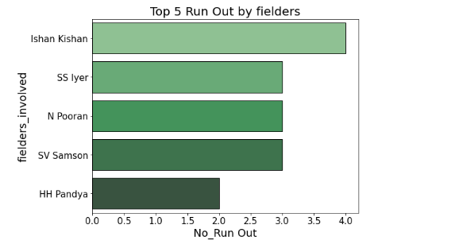**Observations:**

Most Run Out by fielders is Ishan Kishan -4

* **Toss Won**

1. **Most IPL Number of Toss won by Teams.**

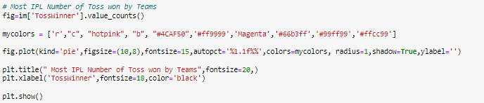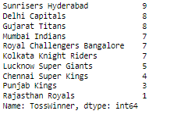

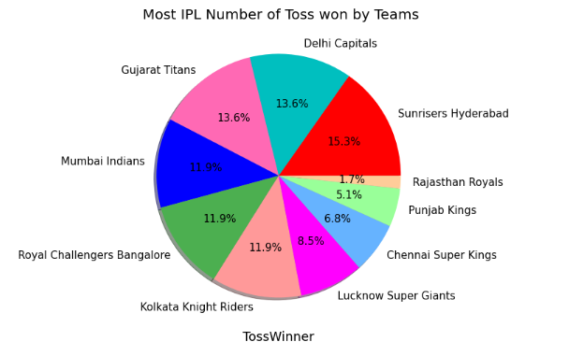**Observations:**

Most IPL Number of Toss won by Teams is Sunrisers Hyderabad -9times

1. **Most Toss won Decisions by Teams**

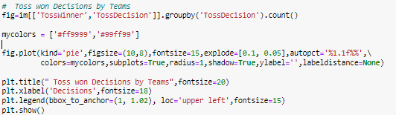

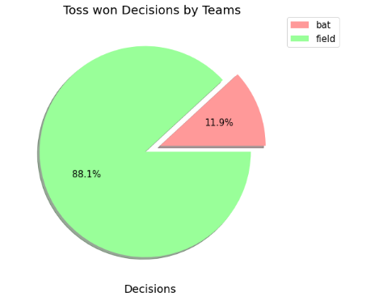

## **Observations:**

Most Toss won Decisions by Teams is Field

**Highest run chase team-wise**.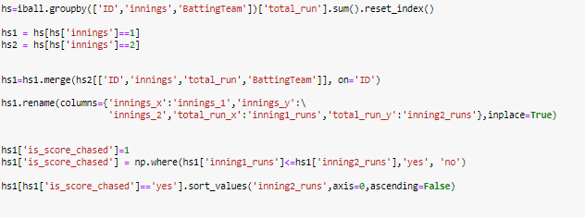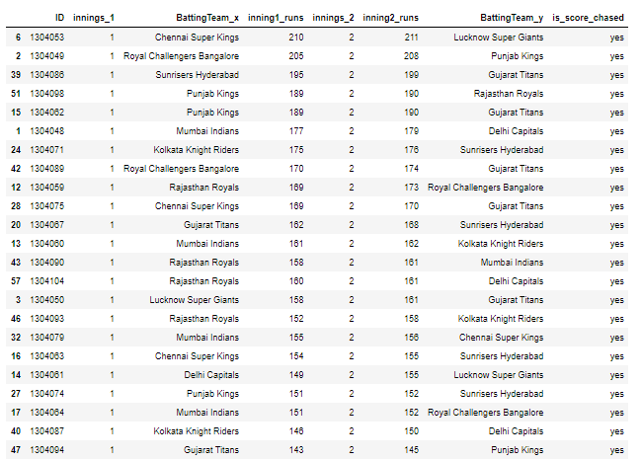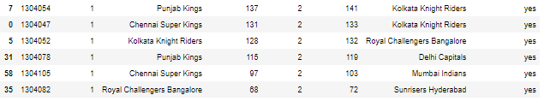

## **Observations:**

Highest run chase team-wise is Chennai Super Kings -210 Runs

**Highest Run scorer in power play and death overs**

**a) Death overs**:

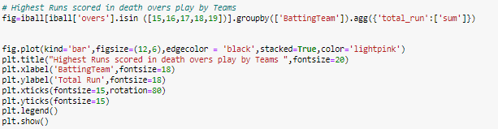

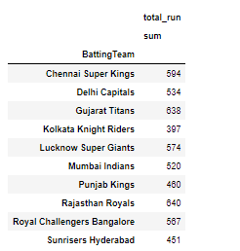

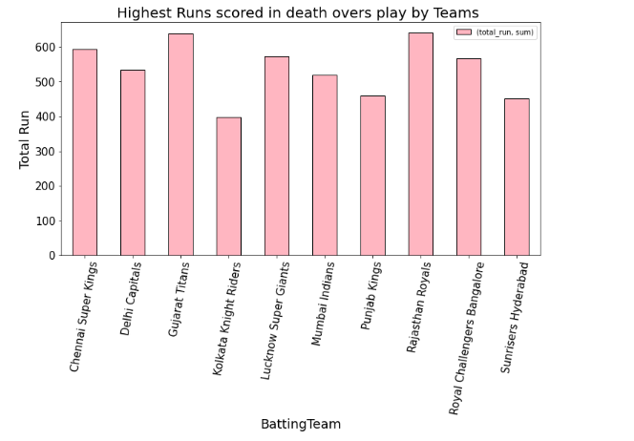

## **Observations:**

Highest Run scorer in Death overs is Rajasthan Royals -640Runs

**b) Power Play:**

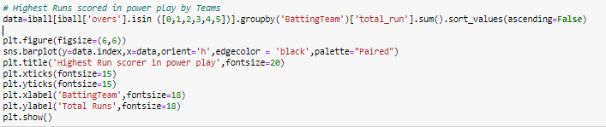

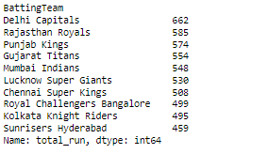

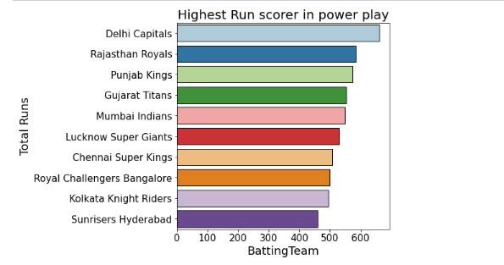

## **Observations:**

Highest Run scorer in Death overs is Delhi Capitals -662Runs

**Most runs scored in 20th and19th overs.**

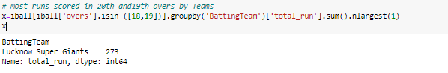

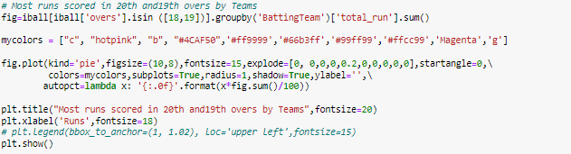

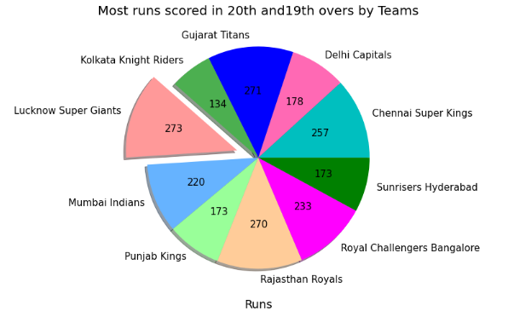

## **Observations:**

Most runs scored in 20th and19th overs is Lucknow Super Giants-273 Runs.

**Does** **winning toss increases the chances of victory.**

**(Match winner after winning the toss)**

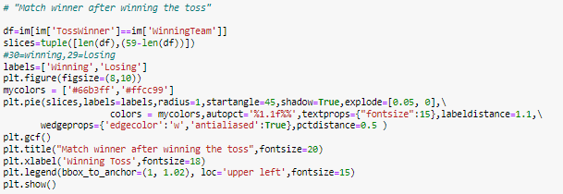

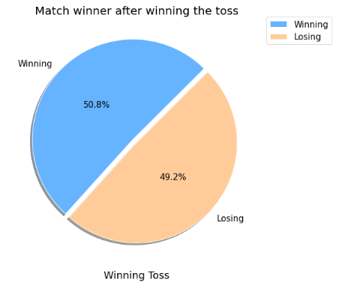

**Observations:**

Winning toss increases the chances of victory is 50.8%

**The Lowest total defended and Highest total chased by each team**

1. **The Lowest total defended**

**a) Match wise**

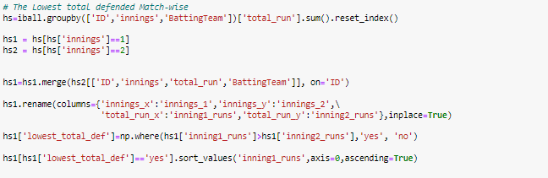

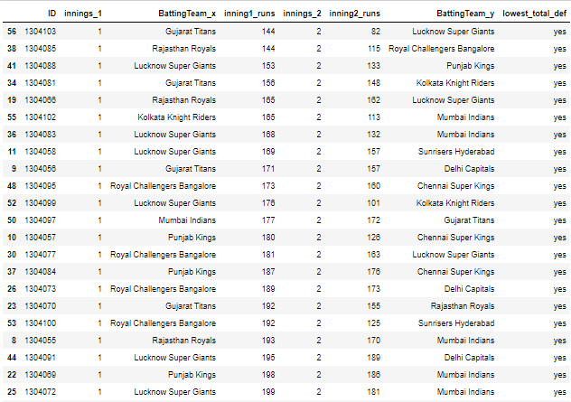

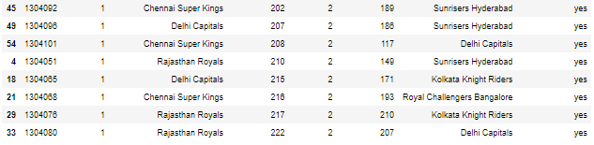

**b) Team wise**

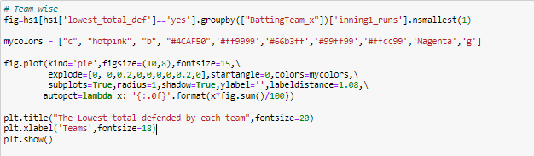

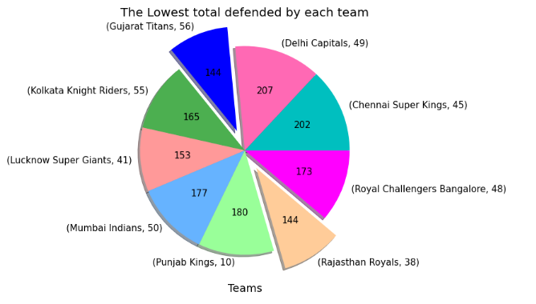**Observations:**

The Lowest total defended teams are Gujarat Titans and Rajasthan Royals -144 Runs.

**2) Highest total chased**

**a) Match wise**

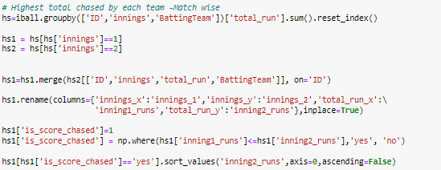

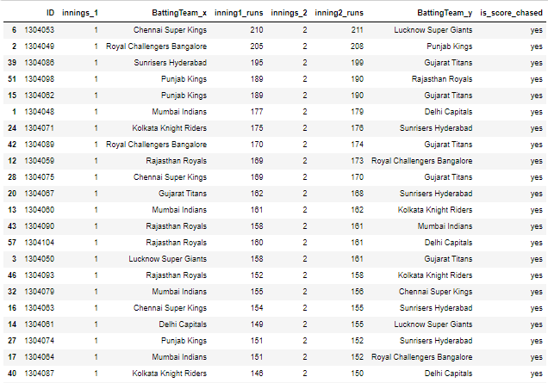

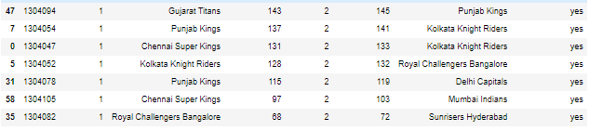

**b) Team wise**

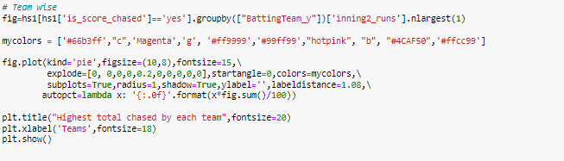

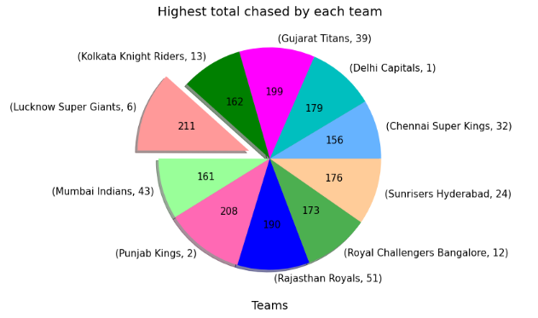

## **Observations:**

The Highest total chased team is Lucknow Super Giants -211 Runs

**Most Sixes and Most Four by individual and teams**

1. **Individuals:**

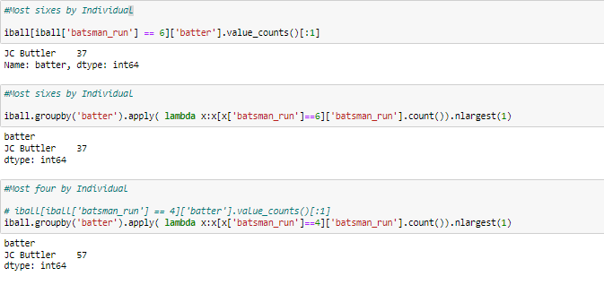

1. **Teams**

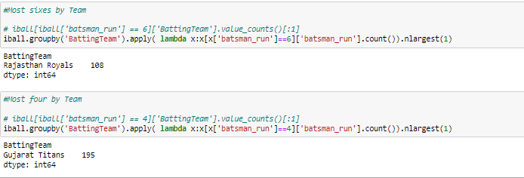

**Most 50+ 100+ partnerships by a duo**

1. **50+ partnerships by a duo**

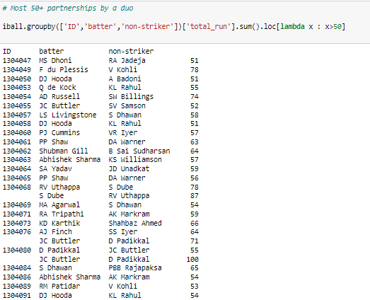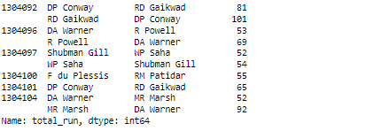

1. **100+ partnerships by a duo**

